
MEMBERS’ CIRCULAR
4 March 2016 Ref. 012/03/16

Dear Members

STUDY TRIP 2016 TO JAKARTA: Tues 24 May to Fri 27 May 2016 (4D/3N)

Greetings from PPK Malaysia !

We are pleased to announce our 2016 short-haul Study Trip to enable personnel in our shopping malls exposure to the exciting shopping malls in JAKARTA, one of the Asian cities with numerous vibrant shopping malls.

Jakarta has countless malls, each with its own niche, ranging from the high end with international brand names to mass malls where you can turn your bargaining skills to good use. They have each created their own ‘community’ with their eclectic merchandise and shopping environments and it is indeed an eye-opening experience to go ‘mall-hopping’ !

Our Study Trip hopes to look at several of these exciting malls and focus on their building design and layouts, and to learn about their marketing events etc.

Details of the above STUDY TRIP 2016 to JAKARTA are as follows:

Duration/Dates | *Cost per pax(RM)  Twin-sharing  (3-4 star hotel) |  | A selection of some of the proposed malls/precincts to visit includes: | Remarks
 | Members | Non-members | - Grand Indonesia  - Senaya City
4D/3N  Proposed flight details (subject to confirmation):  Tues 24 May 2016 :  assemble at KLIA by 0730 (7.30am)  Dep 1040 Arr 1135  Fri 27 May 2016:  Rtn 1935 Arr 2240 | RM2,499 | RM2,999 | - Plaza Senayan  - Gandaria City  - Kota Kasablanka  - Lotte Shopping Avenue  - Pondok Indah Mall  - Lippo Mall Kemang  - Kuningan City Mall  - etc | The trip will only be confirmed with a minimum no. of 35 participants; subject to a maximum of 40 pax.  Climate:  average 28ºC  Single supplement: Additional RM980/-.

Persatuan Pengurusan Kompleks Malaysia (PPK)
Malaysia Shopping Malls Association
A608, 6th Floor, Lobby 2, No. 1, Jalan SS20/27, Damansara Intan, 47400 Petaling Jaya, Selangor D.E. Malaysia
T | +603 7727 6202/6232 | F | +603 7727 6203 | E | secretariat@ppkm.org.my | W | www.ppkm.org.my

The above costs (ex-Kuala Lumpur) includes the following:

- economy flight tickets and check-in luggage of max. 30 kg and carry-on luggage of 5 kg. per pax. (Any extra charges incurred will be borne by the participant personally.)
- airport transfers (in Jakarta)
- 3 nights twin-share accommodation (including breakfast at hotel)
- transport for the above visits to the various shopping malls/precincts (where applicable) but excludes meals and expenses
- travel insurance

Please register as per the attached form together with FULL PAYMENT (payable to Persatuan Pengurusan Kompleks Malaysia (PPK) together with a photocopy of your passport to reach our secretariat on or before 5 p.m. on Friday, 25 March 2016.

Any registrations received after this date will be subject to an administrative surcharge of RM300 per person and subject to availability.

Interested participants are requested to indicate in the attached form in order that we may plan accordingly – please photostat extra copies and IT IS ESSENTIAL TO COMPLETE ONE (1) FORM PER PARTICIPANT WITH ALL DETAILS INDICATED. Kindly note that the entire trip will only be confirmed subject to the required minimum no. of participants and/or flight/hotel availability etc. and on a first-come-first-served basis. We shall keep you posted in due course of further confirmed details concerning the detailed itinerary etc. Kindly also be informed that the organizer reserves the right to revise details of the Study Trip (including departure dates and flight carriers) subject to availability and solely at our discretion.

In the meantime, you may contact our secretariat at Tel: 03-7727 6202 for further information.

Thank you.

Yours faithfully
PERSATUAN PENGURUSAN KOMPLEKS MALAYSIA (PPK)

TAN SRI DATUK EDDY CHEN
President

Appendix 1
JAKARTA: Shopping Malls

1 | Grand Indonesia Shopping Mall opened in 2007 and is one of South East Asia's largest shopping centres with luxury shops and international brands. It is the key component in the mixed development comprising of office towers, 5-star hotels and private residences, covering an area of about 6.9 mil sf. It has 2 main buildings, East and West Mall which are linked by a multi-level bridge covering 6.9 mil sq ft. The shopping centre is spread over 8 levels and is divided into three main districts, Specialty Zone, Main Zone and Crossroads of the World district. Anchor tenants include Central Department Store, Best Denki, blitzmegaplex cinemas., Ranch Market, MUJI and other fashion retailers like Esprit, Zara, H&M etc. The East Mall section has been recently renovated and opened in 2015 with a multitude of F&B outlets. | 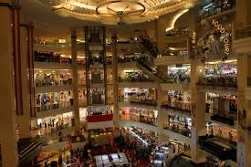
2 | Senayan City Mall is located in Senayan City, an iconic retail, entertainment and lifestyle centre comprising of modern office towers and a luxurious apartment tower sitting on a site of 48,000 sq m. in South Jakarta. The 7-floor high end mall opened in 2006 and has more than 240 stores with a good mix of international and local retail brands, entertainment and food & beverages. | 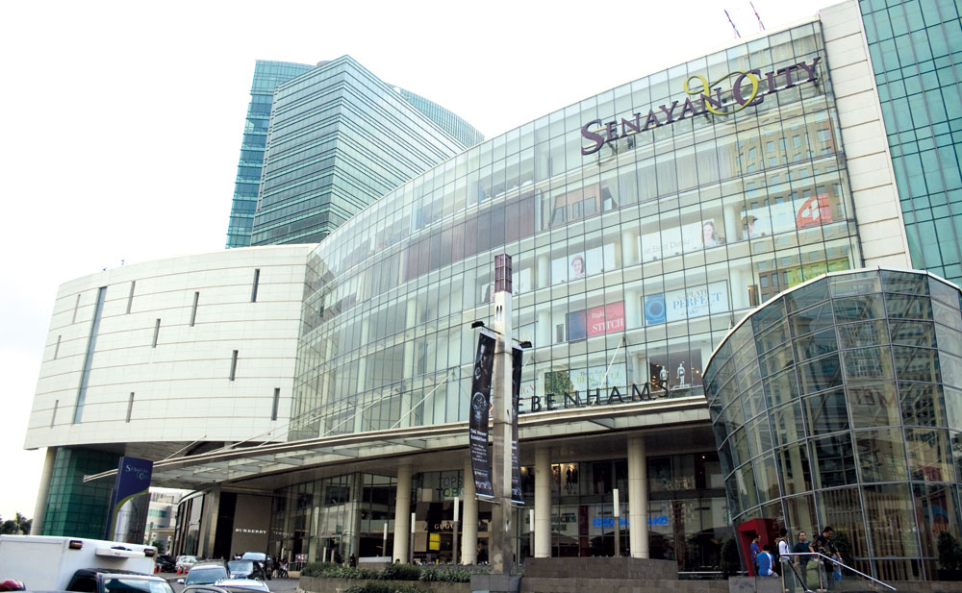
3 | Plaza Senayan opened in 1996 with designer goods and gourmet food and has successfully maintained its status of sophistication and elegance. The award winning mall is located at the South end of Jakarta's Central Business District (CBD) and positioned next two of Jakarta's main thoroughfares. There are 3 anchor tenants and more than 250 shops. In the vicinity are apartment blocks, an entertainment centre and office buildings, overlooking the tranquil Senayan Golf Course and surrounded by several of Jakarta's exclusive residential neighborhoods. | 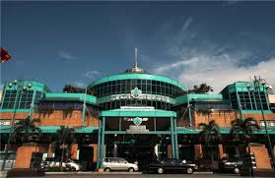

4 | Gandaria City is a mixed use development opened in August 2010, comprising of a shopping mall, an office tower, a 2-tower apartment and Sheraton Hotel. It is strategically located in the prime residential neighborhood and emerging commercial hub of South Jakarta, a few minutes away from CBD area. H&M and IMAX opened their first outlets here with other brands like Furla, Tommy Hilfiger, Hugo Boss, Aigner, Armani Jeans, Uniqlo, Mango, Guess, etc. A major highlight of the mall is the Mainstreet – a lane way dining area offering big names in F&B with various restaurants, cafes, lounges and bars. | 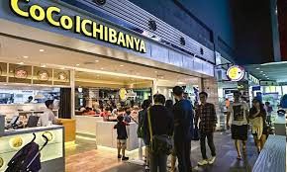
5 | Kota Kasablanka (or popularly known as Kokas) is located in Kuningan, South Jakarta and has been opened since 2014 with affordable, less branded stores over its 6 floors, good for family shoppers, fashion, food and entertainment. Located in a mixed-use project with apartments and office towers (known as ‘super-block’ in Indonesia), the mall’s décor is inspired by Moroccan-style tiles. There are 13 anchor tenants: Sogo, Carrefour, XXI, Amazing Carribean (kids), PaperClip, Chipmunk, Celebrity Fitness, Wall Street Insitute, Ace, INforma, Toys Kingdom, Electronik Solutin, Eat and Eat (food court). | 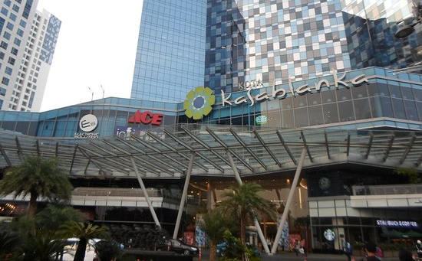
6 | Lotte Shopping Avenue (LoVe) is the 1st shopping centre operated by Lotte Department Store, the no. 1 retailer in Korea. The high end mall opened in 2013 in the centre of Jakarta CBD and is part of Ciputra World 1, a 5.5 hectare integrated mixed-use ‘super-block’ with hotels, residences and apartments. LoVe has a total of 77,000 sq m over 7 floors consisting of fashion, living, culture and entertainment in each area with facilities like fun seating areas, a customer friendly mall directory system, free Wi-Fi, and event halls. With 480 premium brands, shops include Lotte Department Store, Ranch Market, Studio XXI, Lotte Duty Free, Lollipop (for children’s leisure), Best Denki and fashion retailers like UNIQLO, H&M, Guess, Nike, Outlive plus numerous F&B outlets and a food court. | 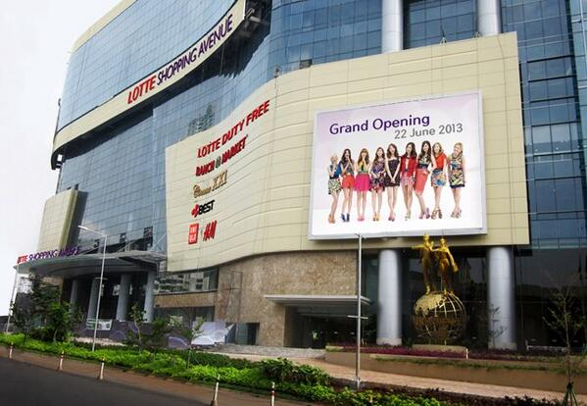

7 | Pondok Indah Mall (PIM) is a large shopping mall located in a South Jakarta suburb and comprises of 2 blocks, PIM1 (3 storeys) & PIM2 (5 storeys) which opened separately in 1991 and 2004. Both blocks are interconnected via 2 elevated multi-storey pedestrian walkways (Skywalk North and Skywalk South) which also are tenanted by specialty shops. There are more than 400 shops, 2 cinemas and an open-air water theme park. PIM's new extension, Street Gallery opened in 2013 and mainly consists of food and beverage tenants. | 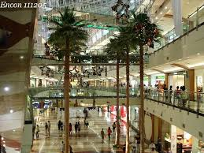
8 | Lippo Mall Kemang opened in December 2012 as a mid-sized mall with a total NLA of 55,000sq m (GLA 80,000sqm) in Kemang Village, a mixed development designed by renowned architects which includes high rise residences, schools, hospitals and several 5-star hotels. It is a fashion and lifestyle mall with 6 anchor tenants and 202 specialty tenants. The anchors include Debenhams Department Store, Hypermart, Cinema XXI, Best Denki, Fitness First Platinum and ACE Hardware. Other major tenants include Marks and Spencer, Timezone, iBox and Eatery Food Court. | 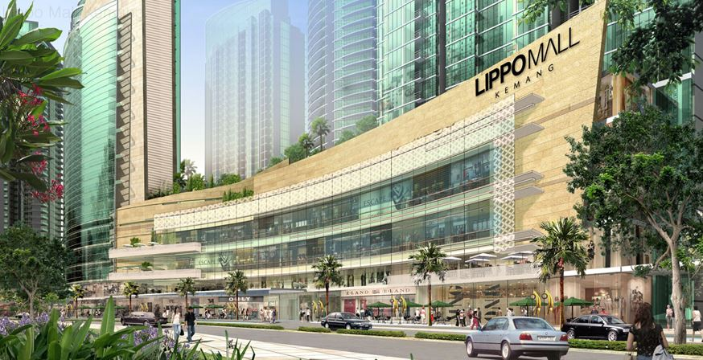
9 | Kuningan City Mall is the retail component of Kuningan City, an integrated complex with high rise apartments and office towers, located in South Jarkarta. There are 2 anchor tenants, ACE Hardware and Jatomi Health and Fitness and more than 220 shops. The mall opened in November 2011 and comprises 6 floors of retail, entertainment and F& B. | 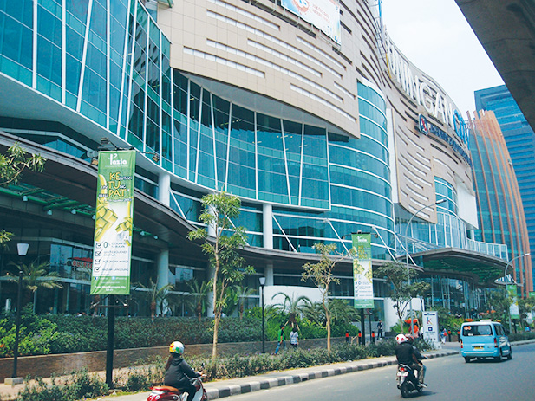

Appendix 2: Registration Form

TO: PPK MALAYSIA Fax: 03-7727 6203
A 608, 6th Floor, Block A, No. 1, Jalan SS20/27
Damansara Intan, 47400 Petaling Jaya

4D/3N STUDY TRIP 2016 TO JAKARTA: Tuesday, 24 May to Friday, 27 May 2016

I am interested in the abovementioned STUDY TRIP 2016 TO JAKARTA as follows:

Name as in NRIC/passport | MR/MS…………………………………………………………………….
Office Tel: | ……………………………………………………………………………..
Handphone No.: | ……………………………………………………………………………..
E-mail address: | ……………………………………………………………………………..
PPK Membership No.: | ……………………………………………………………………………..
Name of Organisation/  Shopping Centre/Building: | ……………………………………………………………………………..
Address: | ……………………………………………………………………………..  ……………………………………………………………………………..  ……………………………………………………………………………..
Designation: | ……………………………………………………………………………..
NRIC No: | ……………………………………………………………………………..
Passport No: | ……………………………………………………………………………..
Expiry Date of Passport::  (kindly ensure minimum of  6 mths validity): | ……………………………………………………………………………..
Enclosed please find my full payment amounting to RM …………payable to Persatuan Pengurusan Kompleks Malaysia (PPK) via cheque No ……………dated ………………..which will be refunded to me only in the event the trip is cancelled by the organizers and not otherwise.
However, in the event I am unable to participate in the trip, I shall undertake to source for a replacement which shall be subject to any differences in payment (if applicable) and final approval by the Committee.
I also understand that the organiser reserves the right to revise details of the Study Trip (including departure dates) subject to availability and at their discretion.

Yours faithfully

………………………………………
Name :
Date :
Company Stamp (if applicable):

Appendix 3

TRAVEL INSURANCE FORM

TO: PPK MALAYSIA Fax: 03-7727 6203
A 608, 6th Floor, Lobby 2, Block A, No. 1, Jalan SS20/27
Damansara Intan, 47400 Petaling Jaya

4D/3N STUDY TRIP 2016 TO JAKARTA: Tuesday, 24 May to Friday, 27 May 2016
TRAVEL INSURANCE

Appended are my details as follows:

Name as in NRIC/passport: | *MR/MS…………………………………………………………………….
NRIC: | …………………………………………………………………………………
Handphone No.: | ………………………………………………………………………………..
E-mail address: | ………………………………………………………………………………..
HOME Address: | ………………………………………………………………………………..  ………………………………………………………………………………..  ………………………………………………………………………………..  ………………………………………………………………………………..
Name of Beneficiary: | *MR/MS .…………………………………………………………………..
NRIC of Beneficiary: | ………………………………………………………………………………..
Relationship: | ………………………………………………………………………………..

I also understand that as per the Schedule of Benefits (available to me upon request), I will not be entitled to any refunds once the policy has been issued in respect of the abovementioned travels.

Yours faithfully

………………………………………
Name :
Date :
*Please delete wherever applicable

